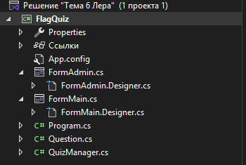
Итоговая структура проекта
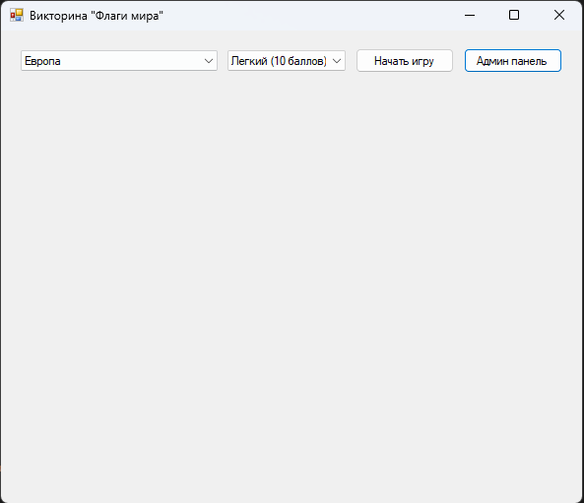
Запуск формы
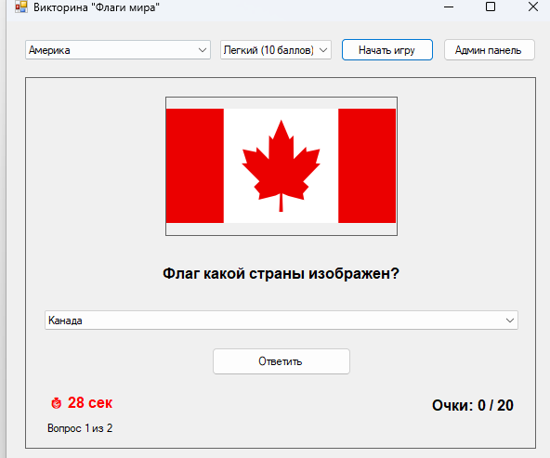
Запуск викторины (таймер+очки)
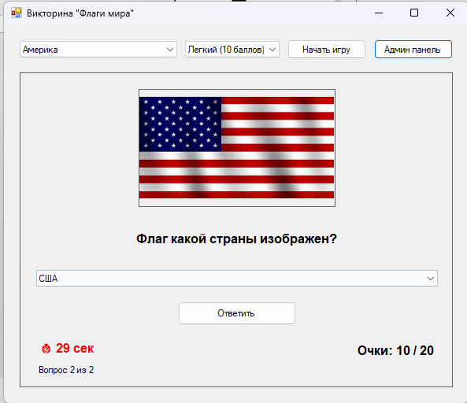
Запуск викторины (таймер+очки)

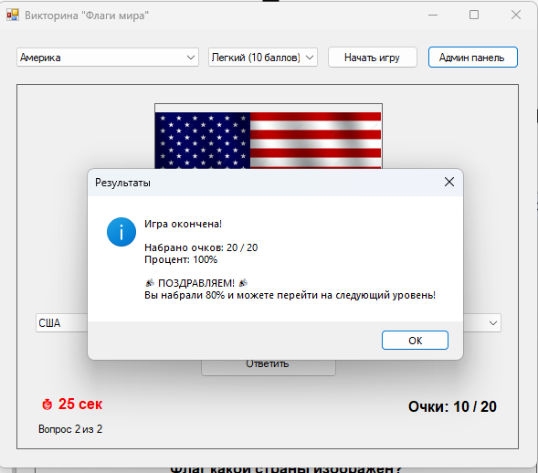
Успешное прохождение
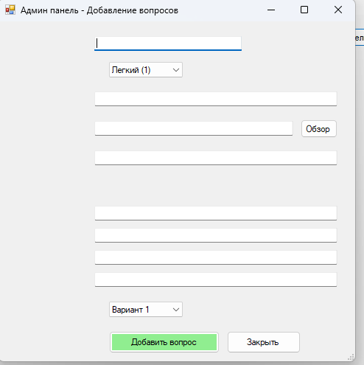
Админ панель где можно добавлять вопросы и фотографии флагов
Код FormAdmin.cs:
using System;
using System.Drawing;
using System.Windows.Forms;

namespace FlagQuiz
{
public partial class FormAdmin : Form
{
private QuizManager quizManager;

// Поля для элементов управления (объявлены в Designer)
private TextBox txtTheme;
private ComboBox cmbLevel;
private TextBox txtQuestion;
private TextBox txtImagePath;
private Button btnBrowseImage;
private TextBox txtHint;
private TextBox txtAnswer1;
private TextBox txtAnswer2;
private TextBox txtAnswer3;
private TextBox txtAnswer4;
private ComboBox cmbCorrectAnswer;
private Button btnAdd;
private Button btnClose;

public FormAdmin(QuizManager manager)
{
quizManager = manager;
InitializeComponent(); // Это вызывает метод из Designer.cs
LoadThemes();
}

private void LoadThemes()
{
// Пустое поле для новой темы
txtTheme.Text = "";
}

private void BtnBrowseImage_Click(object sender, EventArgs e)
{
using (OpenFileDialog ofd = new OpenFileDialog())
{
ofd.Filter = "Изображения (*.png;*.jpg;*.jpeg)|*.png;*.jpg;*.jpeg";
ofd.Title = "Выберите изображение флага";

if (ofd.ShowDialog() == DialogResult.OK)
{
// Копируем файл в папку flags
string destFolder = System.IO.Path.Combine(Application.StartupPath, "flags");
if (!System.IO.Directory.Exists(destFolder))
System.IO.Directory.CreateDirectory(destFolder);

string fileName = System.IO.Path.GetFileName(ofd.FileName);
string destPath = System.IO.Path.Combine(destFolder, fileName);

System.IO.File.Copy(ofd.FileName, destPath, true);
txtImagePath.Text = $"flags/{fileName}";
}
}
}

private void BtnAdd_Click(object sender, EventArgs e)
{
try
{
// Проверка данных
if (string.IsNullOrWhiteSpace(txtTheme.Text))
{
MessageBox.Show("Введите название темы", "Ошибка", MessageBoxButtons.OK, MessageBoxIcon.Warning);
return;
}

if (string.IsNullOrWhiteSpace(txtQuestion.Text))
{
MessageBox.Show("Введите вопрос", "Ошибка", MessageBoxButtons.OK, MessageBoxIcon.Warning);
return;
}

if (string.IsNullOrWhiteSpace(txtAnswer1.Text) || string.IsNullOrWhiteSpace(txtAnswer2.Text))
{
MessageBox.Show("Введите хотя бы два варианта ответа", "Ошибка", MessageBoxButtons.OK, MessageBoxIcon.Warning);
return;
}

// Создание вопроса
Question q = new Question();
q.Text = txtQuestion.Text;
q.ImagePath = txtImagePath.Text;
q.Hint = txtHint.Text;

q.Answers.Add(txtAnswer1.Text);
q.Answers.Add(txtAnswer2.Text);
if (!string.IsNullOrWhiteSpace(txtAnswer3.Text))
q.Answers.Add(txtAnswer3.Text);
if (!string.IsNullOrWhiteSpace(txtAnswer4.Text))
q.Answers.Add(txtAnswer4.Text);

q.CorrectAnswerIndex = cmbCorrectAnswer.SelectedIndex;

// Добавление вопроса
string theme = txtTheme.Text.Trim();
int level = cmbLevel.SelectedIndex + 1;

quizManager.AddQuestion(theme, level, q);

MessageBox.Show("Вопрос успешно добавлен!", "Успех", MessageBoxButtons.OK, MessageBoxIcon.Information);

// Очистка формы
txtQuestion.Clear();
txtImagePath.Clear();
txtHint.Clear();
txtAnswer1.Clear();
txtAnswer2.Clear();
txtAnswer3.Clear();
txtAnswer4.Clear();
cmbCorrectAnswer.SelectedIndex = 0;
}
catch (Exception ex)
{
MessageBox.Show($"Ошибка: {ex.Message}", "Ошибка", MessageBoxButtons.OK, MessageBoxIcon.Error);
}
}
}
}
Код FormAdmin.designer.cs:
using System;
using System.Drawing;
using System.Windows.Forms;

namespace FlagQuiz
{
partial class FormAdmin
{
private System.ComponentModel.IContainer components = null;

// Исправленный метод Dispose
protected override void Dispose(bool disposing)
{
if (disposing && (components != null))
{
components.Dispose();
}
base.Dispose(disposing);
}

#region Windows Form Designer generated code

private void InitializeComponent()
{
this.txtTheme = new TextBox();
this.cmbLevel = new ComboBox();
this.txtQuestion = new TextBox();
this.txtImagePath = new TextBox();
this.btnBrowseImage = new Button();
this.txtHint = new TextBox();
this.txtAnswer1 = new TextBox();
this.txtAnswer2 = new TextBox();
this.txtAnswer3 = new TextBox();
this.txtAnswer4 = new TextBox();
this.cmbCorrectAnswer = new ComboBox();
this.btnAdd = new Button();
this.btnClose = new Button();

this.SuspendLayout();

// txtTheme
this.txtTheme.Location = new Point(130, 20);
this.txtTheme.Size = new Size(200, 20);

// cmbLevel
this.cmbLevel.Location = new Point(150, 55);
this.cmbLevel.Size = new Size(100, 21);
this.cmbLevel.DropDownStyle = ComboBoxStyle.DropDownList;
this.cmbLevel.Items.AddRange(new object[] { "Легкий (1)", "Средний (2)", "Сложный (3)" });
this.cmbLevel.SelectedIndex = 0;

// txtQuestion
this.txtQuestion.Location = new Point(130, 95);
this.txtQuestion.Size = new Size(330, 20);

// txtImagePath
this.txtImagePath.Location = new Point(130, 135);
this.txtImagePath.Size = new Size(270, 20);

// btnBrowseImage
this.btnBrowseImage.Location = new Point(410, 133);
this.btnBrowseImage.Size = new Size(50, 25);
this.btnBrowseImage.Text = "Обзор";

// txtHint
this.txtHint.Location = new Point(130, 175);
this.txtHint.Size = new Size(330, 20);

// txtAnswer1
this.txtAnswer1.Location = new Point(130, 250);
this.txtAnswer1.Size = new Size(330, 20);

// txtAnswer2
this.txtAnswer2.Location = new Point(130, 280);
this.txtAnswer2.Size = new Size(330, 20);

// txtAnswer3
this.txtAnswer3.Location = new Point(130, 310);
this.txtAnswer3.Size = new Size(330, 20);

// txtAnswer4
this.txtAnswer4.Location = new Point(130, 340);
this.txtAnswer4.Size = new Size(330, 20);

// cmbCorrectAnswer
this.cmbCorrectAnswer.Location = new Point(150, 380);
this.cmbCorrectAnswer.Size = new Size(100, 21);
this.cmbCorrectAnswer.DropDownStyle = ComboBoxStyle.DropDownList;
this.cmbCorrectAnswer.Items.AddRange(new object[] { "Вариант 1", "Вариант 2", "Вариант 3", "Вариант 4" });
this.cmbCorrectAnswer.SelectedIndex = 0;

// btnAdd
this.btnAdd.Location = new Point(150, 420);
this.btnAdd.Size = new Size(150, 30);
this.btnAdd.Text = "Добавить вопрос";
this.btnAdd.BackColor = Color.LightGreen;

// btnClose
this.btnClose.Location = new Point(310, 420);
this.btnClose.Size = new Size(100, 30);
this.btnClose.Text = "Закрыть";

// FormAdmin
this.Text = "Админ панель - Добавление вопросов";
this.Size = new Size(500, 500);
this.StartPosition = FormStartPosition.CenterParent;

this.Controls.Add(this.txtTheme);
this.Controls.Add(this.cmbLevel);
this.Controls.Add(this.txtQuestion);
this.Controls.Add(this.txtImagePath);
this.Controls.Add(this.btnBrowseImage);
this.Controls.Add(this.txtHint);
this.Controls.Add(this.txtAnswer1);
this.Controls.Add(this.txtAnswer2);
this.Controls.Add(this.txtAnswer3);
this.Controls.Add(this.txtAnswer4);
this.Controls.Add(this.cmbCorrectAnswer);
this.Controls.Add(this.btnAdd);
this.Controls.Add(this.btnClose);

this.ResumeLayout(false);
}

#endregion
}
}
Код FormMain:
using System;
using System.Drawing;
using System.Windows.Forms;

namespace FlagQuiz
{
public partial class FormMain : Form
{
private QuizManager quizManager;
private Timer questionTimer;
private int timeRemaining;
private bool isGameActive;

// Поля для элементов управления (объявлены в Designer)
private ComboBox cmbTheme;
private ComboBox cmbLevel;
private Button btnStart;
private Button btnAdmin;
private Panel gamePanel;
private PictureBox pictureBoxFlag;
private Label lblQuestion;
private ComboBox cmbAnswers;
private Button btnAnswer;
private Label lblTimer;
private Label lblScore;
private Label lblQuestionNumber;
private Label lblHint;
private Button btnHint;
private Label lblMessage;

public FormMain()
{
InitializeComponent(); // Это вызывает метод из Designer.cs

// Подписка на события
btnStart.Click += BtnStart_Click;
btnAdmin.Click += BtnAdmin_Click;
btnAnswer.Click += BtnAnswer_Click;
btnHint.Click += BtnHint_Click;

// Загрузка XML
try
{
string xmlPath = System.IO.Path.Combine(Application.StartupPath, "data", "flags.xml");
quizManager = new QuizManager(xmlPath);

this.Text = quizManager.QuizTitle;
LoadThemes();
}
catch (Exception ex)
{
MessageBox.Show($"Ошибка загрузки: {ex.Message}", "Ошибка",
MessageBoxButtons.OK, MessageBoxIcon.Error);
}
}

private void LoadThemes()
{
cmbTheme.Items.Clear();
foreach (string theme in quizManager.GetThemes())
{
cmbTheme.Items.Add(theme);
}
if (cmbTheme.Items.Count > 0)
cmbTheme.SelectedIndex = 0;
}

private void BtnStart_Click(object sender, EventArgs e)
{
if (cmbTheme.SelectedItem == null)
{
MessageBox.Show("Выберите тему", "Ошибка", MessageBoxButtons.OK, MessageBoxIcon.Warning);
return;
}

string theme = cmbTheme.SelectedItem.ToString();
int level = cmbLevel.SelectedIndex + 1;

if (!quizManager.HasQuestions(theme, level))
{
MessageBox.Show($"В теме '{theme}' уровня '{cmbLevel.SelectedItem}' нет вопросов",
"Ошибка", MessageBoxButtons.OK, MessageBoxIcon.Warning);
return;
}

// Начать игру
quizManager.StartGame(theme, level, 5);
isGameActive = true;

// Показать игровую панель
gamePanel.Visible = true;

// Настройка таймера
questionTimer = new Timer();
questionTimer.Interval = 1000;
questionTimer.Tick += QuestionTimer_Tick;

// Показать первый вопрос
ShowNextQuestion();
}

private void ShowNextQuestion()
{
if (!quizManager.HasNextQuestion())
{
EndGame();
return;
}

Question q = quizManager.GetCurrentQuestion();
if (q == null) return;

// Обновить UI
lblQuestion.Text = q.Text;
lblQuestionNumber.Text = $"Вопрос {quizManager.CurrentQuestionNumber} из {quizManager.TotalQuestions}";
lblScore.Text = $"Очки: {quizManager.CurrentScore} / {quizManager.MaxScore}";

// Загрузить изображение
try
{
string imagePath = System.IO.Path.Combine(Application.StartupPath, q.ImagePath);
if (System.IO.File.Exists(imagePath))
pictureBoxFlag.Image = Image.FromFile(imagePath);
else
pictureBoxFlag.Image = null;
}
catch
{
pictureBoxFlag.Image = null;
}

// Заполнить варианты ответов
cmbAnswers.Items.Clear();
foreach (string answer in q.Answers)
{
if (!string.IsNullOrEmpty(answer))
cmbAnswers.Items.Add(answer);
}
if (cmbAnswers.Items.Count > 0)
cmbAnswers.SelectedIndex = 0;

// Сбросить подсказку и сообщение
lblHint.Text = "";
lblMessage.Text = "";
btnHint.Enabled = true;

// Запустить таймер
timeRemaining = quizManager.TimePerQuestion;
lblTimer.Text = $"⏱️ {timeRemaining} сек";
questionTimer.Start();
}

private void QuestionTimer_Tick(object sender, EventArgs e)
{
timeRemaining--;
lblTimer.Text = $"⏱️ {timeRemaining} сек";

if (timeRemaining <= 0)
{
questionTimer.Stop();
TimeOut();
}
}

private void TimeOut()
{
lblMessage.Text = "⏰ Время вышло!";
lblMessage.ForeColor = Color.Red;
btnAnswer.Enabled = false;
btnHint.Enabled = false;

Timer delayTimer = new Timer();
delayTimer.Interval = 1500;
delayTimer.Tick += (delaySender, delayArgs) =>
{
delayTimer.Stop();
btnAnswer.Enabled = true;
ContinueAfterAnswer();
};
delayTimer.Start();
}

private void BtnAnswer_Click(object sender, EventArgs e)
{
if (cmbAnswers.SelectedIndex == -1) return;

questionTimer.Stop();

int selectedIndex = cmbAnswers.SelectedIndex;
int earnedPoints;
bool isCorrect = quizManager.AnswerCurrentQuestion(selectedIndex, out earnedPoints);

if (isCorrect)
{
lblMessage.Text = $"✓ Правильно! +{earnedPoints} очков";
lblMessage.ForeColor = Color.Green;
}
else
{
string correctAnswer = quizManager.GetCurrentQuestion()?.GetCorrectAnswer() ?? "";
lblMessage.Text = $"✗ Неправильно! Правильный ответ: {correctAnswer}";
lblMessage.ForeColor = Color.Red;
}

btnAnswer.Enabled = false;
btnHint.Enabled = false;

Timer delayTimer = new Timer();
delayTimer.Interval = 1500;
delayTimer.Tick += (delaySender, delayArgs) =>
{
delayTimer.Stop();
btnAnswer.Enabled = true;
ContinueAfterAnswer();
};
delayTimer.Start();
}

private void ContinueAfterAnswer()
{
if (quizManager.HasNextQuestion())
{
ShowNextQuestion();
}
else
{
EndGame();
}
}

private void BtnHint_Click(object sender, EventArgs e)
{
Question q = quizManager.GetCurrentQuestion();
if (q != null && !string.IsNullOrEmpty(q.Hint))
{
lblHint.Text = $"💡 Подсказка: {q.Hint}";
btnHint.Enabled = false;
}
else
{
lblHint.Text = "💡 Подсказка отсутствует";
}
}

private void EndGame()
{
questionTimer?.Stop();
isGameActive = false;

int percentage = quizManager.GetPercentage();
bool canAdvance = quizManager.CanAdvanceToNextLevel();

string message = $"Игра окончена!\n\n";
message += $"Набрано очков: {quizManager.CurrentScore} / {quizManager.MaxScore}\n";
message += $"Процент: {percentage}%\n\n";

if (canAdvance)
{
message += "🎉 ПОЗДРАВЛЯЕМ! 🎉\n";
message += "Вы набрали 80% и можете перейти на следующий уровень!";
}
else
{
message += "😞 К сожалению, вы не набрали 80%.\n";
message += "Попробуйте еще раз!";
}

MessageBox.Show(message, "Результаты", MessageBoxButtons.OK,
canAdvance ? MessageBoxIcon.Information : MessageBoxIcon.Warning);

gamePanel.Visible = false;
}

private void BtnAdmin_Click(object sender, EventArgs e)
{
FormAdmin adminForm = new FormAdmin(quizManager);
adminForm.ShowDialog();
}
}
}
Код FormMain.designer.cs:
using System;
using System.Drawing;
using System.Windows.Forms;

namespace FlagQuiz
{
partial class FormMain
{
private System.ComponentModel.IContainer components = null;

// Исправленный метод Dispose
protected override void Dispose(bool disposing)
{
if (disposing && (components != null))
{
components.Dispose();
}
base.Dispose(disposing);
}

#region Windows Form Designer generated code

private void InitializeComponent()
{
this.cmbTheme = new ComboBox();
this.cmbLevel = new ComboBox();
this.btnStart = new Button();
this.btnAdmin = new Button();
this.gamePanel = new Panel();
this.lblHint = new Label();
this.btnHint = new Button();
this.lblMessage = new Label();
this.lblQuestionNumber = new Label();
this.lblScore = new Label();
this.lblTimer = new Label();
this.btnAnswer = new Button();
this.cmbAnswers = new ComboBox();
this.lblQuestion = new Label();
this.pictureBoxFlag = new PictureBox();

this.SuspendLayout();

// cmbTheme
this.cmbTheme.Location = new Point(20, 20);
this.cmbTheme.Size = new Size(200, 21);
this.cmbTheme.DropDownStyle = ComboBoxStyle.DropDownList;

// cmbLevel
this.cmbLevel.Location = new Point(230, 20);
this.cmbLevel.Size = new Size(120, 21);
this.cmbLevel.DropDownStyle = ComboBoxStyle.DropDownList;
this.cmbLevel.Items.AddRange(new object[] { "Легкий (10 баллов)", "Средний (20 баллов)", "Сложный (30 баллов)" });
this.cmbLevel.SelectedIndex = 0;

// btnStart
this.btnStart.Location = new Point(360, 18);
this.btnStart.Size = new Size(100, 25);
this.btnStart.Text = "Начать игру";

// btnAdmin
this.btnAdmin.Location = new Point(470, 18);
this.btnAdmin.Size = new Size(100, 25);
this.btnAdmin.Text = "Админ панель";

// gamePanel
this.gamePanel.Location = new Point(20, 60);
this.gamePanel.Size = new Size(550, 400);
this.gamePanel.BorderStyle = BorderStyle.FixedSingle;
this.gamePanel.Visible = false;

// pictureBoxFlag
this.pictureBoxFlag.Location = new Point(150, 20);
this.pictureBoxFlag.Size = new Size(250, 150);
this.pictureBoxFlag.SizeMode = PictureBoxSizeMode.Zoom;
this.pictureBoxFlag.BorderStyle = BorderStyle.FixedSingle;

// lblQuestion
this.lblQuestion.Location = new Point(20, 190);
this.lblQuestion.Size = new Size(510, 40);
this.lblQuestion.Font = new Font("Arial", 12, FontStyle.Bold);
this.lblQuestion.TextAlign = ContentAlignment.MiddleCenter;

// cmbAnswers
this.cmbAnswers.Location = new Point(20, 250);
this.cmbAnswers.Size = new Size(510, 21);
this.cmbAnswers.DropDownStyle = ComboBoxStyle.DropDownList;

// btnAnswer
this.btnAnswer.Location = new Point(200, 290);
this.btnAnswer.Size = new Size(150, 30);
this.btnAnswer.Text = "Ответить";

// lblTimer
this.lblTimer.Location = new Point(20, 340);
this.lblTimer.Size = new Size(150, 25);
this.lblTimer.Font = new Font("Arial", 12, FontStyle.Bold);
this.lblTimer.ForeColor = Color.Red;

// lblScore
this.lblScore.Location = new Point(380, 340);
this.lblScore.Size = new Size(150, 25);
this.lblScore.Font = new Font("Arial", 12, FontStyle.Bold);
this.lblScore.TextAlign = ContentAlignment.MiddleRight;

// lblQuestionNumber
this.lblQuestionNumber.Location = new Point(20, 370);
this.lblQuestionNumber.Size = new Size(200, 20);

// lblHint
this.lblHint.Location = new Point(20, 400);
this.lblHint.Size = new Size(400, 40);
this.lblHint.ForeColor = Color.Gray;
this.lblHint.Font = new Font("Arial", 9, FontStyle.Italic);

// btnHint
this.btnHint.Location = new Point(430, 400);
this.btnHint.Size = new Size(100, 25);
this.btnHint.Text = "Подсказка";

// lblMessage
this.lblMessage.Location = new Point(20, 440);
this.lblMessage.Size = new Size(510, 30);
this.lblMessage.Font = new Font("Arial", 10, FontStyle.Bold);
this.lblMessage.TextAlign = ContentAlignment.MiddleCenter;

// Добавление элементов на gamePanel
this.gamePanel.Controls.Add(this.pictureBoxFlag);
this.gamePanel.Controls.Add(this.lblQuestion);
this.gamePanel.Controls.Add(this.cmbAnswers);
this.gamePanel.Controls.Add(this.btnAnswer);
this.gamePanel.Controls.Add(this.lblTimer);
this.gamePanel.Controls.Add(this.lblScore);
this.gamePanel.Controls.Add(this.lblQuestionNumber);
this.gamePanel.Controls.Add(this.lblHint);
this.gamePanel.Controls.Add(this.btnHint);
this.gamePanel.Controls.Add(this.lblMessage);

// FormMain
this.ClientSize = new Size(590, 480);
this.Controls.Add(this.gamePanel);
this.Controls.Add(this.btnAdmin);
this.Controls.Add(this.btnStart);
this.Controls.Add(this.cmbLevel);
this.Controls.Add(this.cmbTheme);
this.Text = "Викторина: Флаги мира";
this.StartPosition = FormStartPosition.CenterScreen;

this.ResumeLayout(false);
}

#endregion
}
}
Код Question.cs:
using System;
using System.Collections.Generic;

namespace FlagQuiz
{
/// <summary>
/// Класс вопроса викторины
/// </summary>
public class Question
{
private string text;
private string imagePath;
private string hint;
private List<string> answers;
private int correctAnswerIndex;

public Question()
{
answers = new List<string>();
correctAnswerIndex = -1;
}

public string Text
{
get { return text; }
set { text = value; }
}

public string ImagePath
{
get { return imagePath; }
set { imagePath = value; }
}

public string Hint
{
get { return hint; }
set { hint = value; }
}

public List<string> Answers
{
get { return answers; }
set { answers = value; }
}

public int CorrectAnswerIndex
{
get { return correctAnswerIndex; }
set { correctAnswerIndex = value; }
}

public string GetCorrectAnswer()
{
if (correctAnswerIndex >= 0 && correctAnswerIndex < answers.Count)
return answers[correctAnswerIndex];
return "";
}

public bool IsCorrect(int selectedIndex)
{
return selectedIndex == correctAnswerIndex;
}
}
}
Код QuizManager.cs:
using System;
using System.Collections.Generic;
using System.IO;
using System.Linq;
using System.Xml;
using System.Windows.Forms;

namespace FlagQuiz
{
/// <summary>
/// Класс для управления викториной
/// </summary>
public class QuizManager
{
private string xmlFilePath;
private string quizTitle;
private string quizDescription;

// Структура: тема -> уровень сложности -> список вопросов
private Dictionary<string, Dictionary<int, List<Question>>> questions;
private List<string> themes;

// Параметры текущей игры
private string currentTheme;
private int currentLevel;
private List<Question> currentQuestions;
private int currentQuestionIndex;
private int currentScore;
private int totalQuestions;
private int pointsPerQuestion;
private int timePerQuestion;

// Случайный генератор
private Random random;

public QuizManager(string xmlPath)
{
xmlFilePath = xmlPath;
questions = new Dictionary<string, Dictionary<int, List<Question>>>();
themes = new List<string>();
random = new Random();
LoadXml();
}

/// <summary>
/// Загрузка XML файла
/// </summary>
private void LoadXml()
{
if (!File.Exists(xmlFilePath))
{
throw new Exception($"Файл {xmlFilePath} не найден!");
}

XmlDocument doc = new XmlDocument();
doc.Load(xmlFilePath);

// Заголовок
XmlNode titleNode = doc.SelectSingleNode("//title");
if (titleNode != null)
quizTitle = titleNode.InnerText;

XmlNode descNode = doc.SelectSingleNode("//description");
if (descNode != null)
quizDescription = descNode.InnerText;

// Загрузка тем
XmlNodeList themeNodes = doc.SelectNodes("//themes/theme");
foreach (XmlNode themeNode in themeNodes)
{
string themeName = themeNode.Attributes["name"]?.Value;
if (string.IsNullOrEmpty(themeName)) continue;

themes.Add(themeName);
questions[themeName] = new Dictionary<int, List<Question>>();

// Загрузка уровней
XmlNodeList levelNodes = themeNode.SelectNodes("level");
foreach (XmlNode levelNode in levelNodes)
{
int difficulty = int.Parse(levelNode.Attributes["difficulty"]?.Value ?? "1");
questions[themeName][difficulty] = new List<Question>();

// Загрузка вопросов
XmlNodeList questionNodes = levelNode.SelectNodes("question");
foreach (XmlNode qNode in questionNodes)
{
Question q = new Question();

// Текст вопроса
XmlNode textNode = qNode.SelectSingleNode("text");
if (textNode != null)
q.Text = textNode.InnerText;

// Изображение
XmlNode imageNode = qNode.SelectSingleNode("image");
if (imageNode != null)
q.ImagePath = imageNode.InnerText;

// Подсказка
XmlNode hintNode = qNode.SelectSingleNode("hint");
if (hintNode != null)
q.Hint = hintNode.InnerText;

// Варианты ответов
XmlNodeList answerNodes = qNode.SelectNodes("answers/answer");
int answerIndex = 0;
foreach (XmlNode aNode in answerNodes)
{
string answerText = aNode.InnerText;
q.Answers.Add(answerText);

if (aNode.Attributes["correct"]?.Value == "true")
q.CorrectAnswerIndex = answerIndex;

answerIndex++;
}

questions[themeName][difficulty].Add(q);
}
}
}
}

/// <summary>
/// Получить список тем
/// </summary>
public List<string> GetThemes()
{
return themes;
}

/// <summary>
/// Получить название викторины
/// </summary>
public string QuizTitle
{
get { return quizTitle; }
}

/// <summary>
/// Получить описание
/// </summary>
public string QuizDescription
{
get { return quizDescription; }
}

/// <summary>
/// Проверить, есть ли вопросы для темы и уровня
/// </summary>
public bool HasQuestions(string theme, int level)
{
if (!questions.ContainsKey(theme)) return false;
if (!questions[theme].ContainsKey(level)) return false;
return questions[theme][level].Count > 0;
}

/// <summary>
/// Начать игру
/// </summary>
public void StartGame(string theme, int level, int questionsToTake = 5)
{
currentTheme = theme;
currentLevel = level;

if (!questions.ContainsKey(theme) || !questions[theme].ContainsKey(level))
throw new Exception("Нет вопросов для выбранной темы и уровня");

// Получить все вопросы уровня
List<Question> allQuestions = new List<Question>(questions[theme][level]);

// Перемешать вопросы
currentQuestions = allQuestions.OrderBy(x => random.Next()).Take(questionsToTake).ToList();

currentQuestionIndex = 0;
currentScore = 0;
totalQuestions = currentQuestions.Count;

// Параметры уровня
XmlDocument doc = new XmlDocument();
doc.Load(xmlFilePath);
XmlNode levelNode = doc.SelectSingleNode($"//theme[@name='{theme}']/level[@difficulty='{level}']");

if (levelNode != null)
{
pointsPerQuestion = int.Parse(levelNode.Attributes["points_per_question"]?.Value ?? "10");
timePerQuestion = int.Parse(levelNode.Attributes["time_seconds"]?.Value ?? "30");
}
}

/// <summary>
/// Получить текущий вопрос
/// </summary>
public Question GetCurrentQuestion()
{
if (currentQuestionIndex < currentQuestions.Count)
return currentQuestions[currentQuestionIndex];
return null;
}

/// <summary>
/// Ответить на вопрос
/// </summary>
public bool AnswerCurrentQuestion(int answerIndex, out int earnedPoints)
{
Question q = GetCurrentQuestion();
earnedPoints = 0;

if (q == null) return false;

bool isCorrect = q.IsCorrect(answerIndex);
if (isCorrect)
{
earnedPoints = pointsPerQuestion;
currentScore += earnedPoints;
}

currentQuestionIndex++;
return isCorrect;
}

/// <summary>
/// Есть ли следующий вопрос
/// </summary>
public bool HasNextQuestion()
{
return currentQuestionIndex < currentQuestions.Count;
}

/// <summary>
/// Получить текущий счет
/// </summary>
public int CurrentScore
{
get { return currentScore; }
}

/// <summary>
/// Получить максимальный балл
/// </summary>
public int MaxScore
{
get { return totalQuestions * pointsPerQuestion; }
}

/// <summary>
/// Получить процент правильных ответов
/// </summary>
public int GetPercentage()
{
if (totalQuestions == 0) return 0;
return (currentScore * 100) / MaxScore;
}

/// <summary>
/// Получить количество вопросов в текущем сеансе
/// </summary>
public int TotalQuestions
{
get { return totalQuestions; }
}

/// <summary>
/// Получить номер текущего вопроса (1-based)
/// </summary>
public int CurrentQuestionNumber
{
get { return currentQuestionIndex + 1; }
}

/// <summary>
/// Получить время на вопрос (секунд)
/// </summary>
public int TimePerQuestion
{
get { return timePerQuestion; }
}

/// <summary>
/// Получить очки за вопрос
/// </summary>
public int PointsPerQuestion
{
get { return pointsPerQuestion; }
}

/// <summary>
/// Получить текущую тему
/// </summary>
public string CurrentTheme
{
get { return currentTheme; }
}

/// <summary>
/// Получить текущий уровень
/// </summary>
public int CurrentLevel
{
get { return currentLevel; }
}

/// <summary>
/// Проверить, можно ли перейти на следующий уровень (нужно 80% баллов)
/// </summary>
public bool CanAdvanceToNextLevel()
{
return GetPercentage() >= 80;
}

/// <summary>
/// Добавить новый вопрос (для админа)
/// </summary>
public void AddQuestion(string theme, int level, Question question)
{
if (!questions.ContainsKey(theme))
{
questions[theme] = new Dictionary<int, List<Question>>();
themes.Add(theme);
}

if (!questions[theme].ContainsKey(level))
{
questions[theme][level] = new List<Question>();
}

questions[theme][level].Add(question);

// Сохранить в XML
SaveToXml();
}

/// <summary>
/// Сохранить данные в XML
/// </summary>
private void SaveToXml()
{
XmlDocument doc = new XmlDocument();

// Корневой элемент
XmlElement root = doc.CreateElement("quiz");
doc.AppendChild(root);

// Заголовок
XmlElement titleElem = doc.CreateElement("title");
titleElem.InnerText = quizTitle;
root.AppendChild(titleElem);

// Описание
XmlElement descElem = doc.CreateElement("description");
descElem.InnerText = quizDescription;
root.AppendChild(descElem);

// Темы
XmlElement themesElem = doc.CreateElement("themes");
root.AppendChild(themesElem);

foreach (string themeName in themes)
{
XmlElement themeElem = doc.CreateElement("theme");
themeElem.SetAttribute("name", themeName);
themesElem.AppendChild(themeElem);

foreach (var levelPair in questions[themeName])
{
XmlElement levelElem = doc.CreateElement("level");
levelElem.SetAttribute("difficulty", levelPair.Key.ToString());
levelElem.SetAttribute("name", levelPair.Key == 1 ? "Легкий" : (levelPair.Key == 2 ? "Средний" : "Сложный"));
levelElem.SetAttribute("points_per_question", (levelPair.Key == 1 ? "10" : (levelPair.Key == 2 ? "20" : "30")));
levelElem.SetAttribute("time_seconds", (levelPair.Key == 1 ? "30" : (levelPair.Key == 2 ? "20" : "15")));
themeElem.AppendChild(levelElem);

foreach (Question q in levelPair.Value)
{
XmlElement qElem = doc.CreateElement("question");
levelElem.AppendChild(qElem);

XmlElement textElem = doc.CreateElement("text");
textElem.InnerText = q.Text;
qElem.AppendChild(textElem);

XmlElement imageElem = doc.CreateElement("image");
imageElem.InnerText = q.ImagePath;
qElem.AppendChild(imageElem);

XmlElement hintElem = doc.CreateElement("hint");
hintElem.InnerText = q.Hint;
qElem.AppendChild(hintElem);

XmlElement answersElem = doc.CreateElement("answers");
qElem.AppendChild(answersElem);

for (int i = 0; i < q.Answers.Count; i++)
{
XmlElement aElem = doc.CreateElement("answer");
if (i == q.CorrectAnswerIndex)
aElem.SetAttribute("correct", "true");
aElem.InnerText = q.Answers[i];
answersElem.AppendChild(aElem);
}
}
}
}

doc.Save(xmlFilePath);
}
}
}

